Fish Tank Monitor

Savannah Tanner, Caleb Neill, Astrid Delestine

10/19/2023

Table of Contents

**Executive Summary 3**

**1 Project Overview 4**

1.1 Description 4

1.2 Team Contacts and Protocols 5

1.2.1 Diversity, Equity, and Inclusion Statement 5

1.2.2 Communication Analysis 5

1.3 Gap Analysis 6

1.4 Timeline and Task List 7

1.5 References and Task List 8

1.5.1 References (IEEE) 8

1.5.2 File Links 8

1.6 Revision Table 9

# Executive Summary

Our project is an all-in-one fish tank monitor. It will consist of multiple internal sensors and a system to log water parameter paper test results and display them in an organized form. We are aiming to make the product inexpensive and user friendly to ensure that all fish hobbyists can feel comfortable managing their fish tank’s array of parameters in order to keep their pets healthy.

The monitor will track a variety of parameters including the level of nitrites, nitrates, ammonia, salinity, pH, temperature, and lighting. It will also include a feeding and cleaning schedule function and log test results. These test results will be exportable through a micro-USB. The device will test various parameters with a color sensor and testing strips, allowing the device to allow for further accessibility. The user interface will consist of a screen with a series of buttons so that all users can easily navigate their options and care for their tank appropriately.

# 1 Project Overview

## 1.1 Description

Our fish tank monitoring system is designed to track and log aquarium parameters including the presence of nitrites, nitrates, and ammonia as well as the pH, temperature, lux, and salinity levels. The system provides real-time alerts for poor water quality, feeding, and cleaning. The device includes a user-friendly interface to help aquarium hobbyists track the health of their tank daily as well as over time. The device reduces the need for manual testing and combines several testing methods into a single device, enhancing the overall experience for fish enthusiasts.

## 1.2 Team Contacts and Protocols

### 1.2.1 Diversity, Equity, and Inclusion Statement

The Fish Tank Monitor Project is committed to fostering a sense of diversity, equity, and inclusivity. We prioritize equitable design and accessibility, seeking to design our project with all backgrounds and resources in mind. We value diverse opinions and various perspectives for collaboration. We strive to ensure we are providing equal opportunities and experiences to create a product that is accessible and fair to all. DEI is an integral part of our project, ensuring that our work benefits all who care for aquatic life.

### 1.2.2 Communication Analysis

The target market for this product would include fish tank hobbyists, fish sellers, and large scale aquarium owners. The hobbyists may not have as much technical expertise as fish sellers so the communication should be concise and free of most technical jargon. Regular communication through email is preferred so that they can be updated on project improvements as they are made. Retailers and fish sellers are interested in the product’s pricing, marketing materials, and availability. They may also lack certain technical expertise so communication should remain free of technical jargon, but include more information about the advancements of the product from a marketing standpoint. Large-scale aquarium owners would require updates on the capabilities of the product and the scale at which it is operational. Larger aquariums require different varieties of testing, so this would mean updates similar to those of the hobbyists.

## 1.3 Gap Analysis

There is a gap in the market because there are no existing products capable of measuring and monitoring all of the values and variables we seek to with our project in a single integrated system. Fish tank enthusiasts often require multiple devices to properly care for their aquariums, so developing a single comprehensive monitoring system would cause users to not need to invest in several products and would instead only need one system. This would make the process of maintaining a healthy fish tank more convenient and cost-effective.

## 1.4 Timeline and Task List

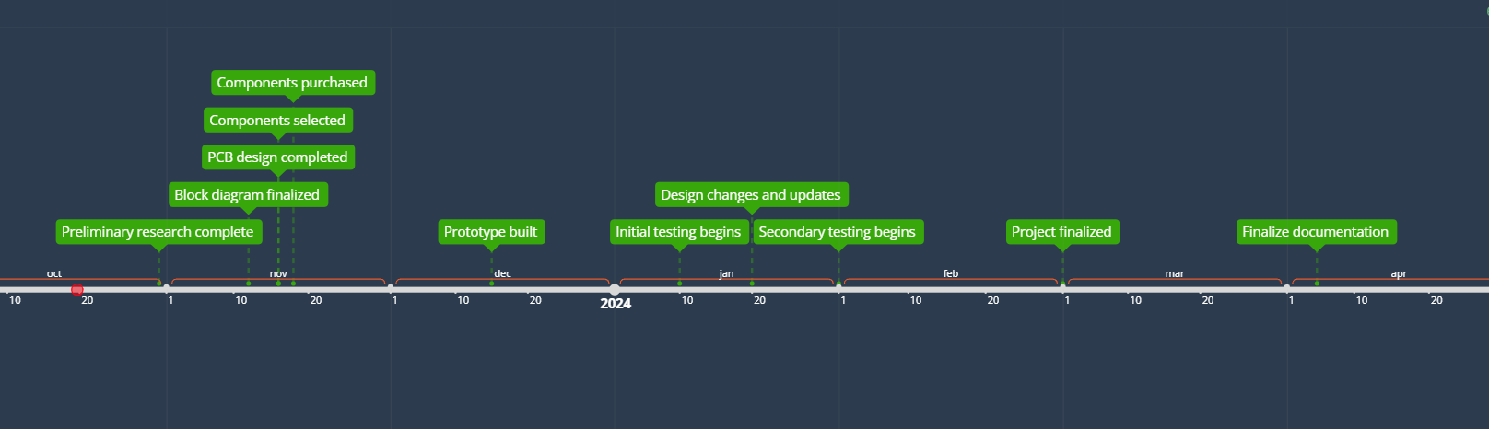

| **Task Description** | **Impact Risk** | **Expected Hours** | **Due Date** | **Champion** | **Actual Work Hours** |
| --- | --- | --- | --- | --- | --- |
| research how to implement sensors | 8 | 2 | 10/21 |  |  |
| research components for temperature, nitrate, ammonia, lux, nitrite, pH, and salinity sensors | 7 | 2 | 10/21 |  |  |
| research the use of the ESP32 (datasheets, other projects, etc) | 8 | 3 | 10/21 |  |  |
| create a list of required components (draft) | 6 | 1 | 10/21 |  |  |
| explore data processing methods | 6 | 2 | 10/25 |  |  |
| conduct market research | 7 | 3 | 10/25 |  |  |
| initial user interface design | 8 | 3 | 10/25 |  |  |
| research programming language options | 8 | 2 | 10/25 |  |  |
| assess power requirements | 8 | 2 | 10/28 |  |  |

## 1.5 References and File Links

### 1.5.1 References (IEEE)

[1] AlfredH1 and Instructables, “Everything you need to know about colour sensors,” Instructables, https://www.instructables.com/Everything-you-need-to-know-about-colour-sensors/ (accessed Oct. 19, 2023).

[2] “Detection based on ‘light’what is a color sensor?,” KEYENCE, https://www.keyence.com/ss/products/sensor/sensorbasics/color/info/ (accessed Oct. 19, 2023).

### 1.5.2 File Links

[ESP32 Datasheet](https://drive.google.com/file/d/1LZmSpgBcTSkA72qA32ZNZrJ2Q4c14Vzr/view?usp=share_link)

[Color Sensor Notes](https://docs.google.com/document/d/1tmPK-S2oo9aXApMzLYQliIJt_JYLfn_S148TjRFearc/edit?usp=sharing)

## 1.6 Revision Table

| 10/19/2023 | Savannah Tanner, Caleb Neill, Astrid Delestine: section 1 draft completion |
| --- | --- |
| 10/19/2023 | Savannah Tanner: initial document creation |